Practical 1 : RSA Encryption and Decryption Using Online Tool

Aim
To perform encryption and decryption using the RSA algorithm with the help of an online tool.

Theory
RSA algorithm is an asymmetric encryption technique that uses:
- Public Key → for encryption
- Private Key → for decryption
It ensures secure communication over networks.

Tool Used
- RSA Encryption Tool (8gwifi.org)

Practical Steps

Step 1: Open the Tool
- Go to the RSA online tool website (8gwifi RSA tool)
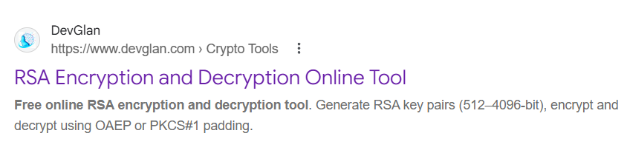

Step 2: Generate Keys
- Click on “Generate RSA Key Pair”
- The tool will generate:
  - Public Key
  - Private Key
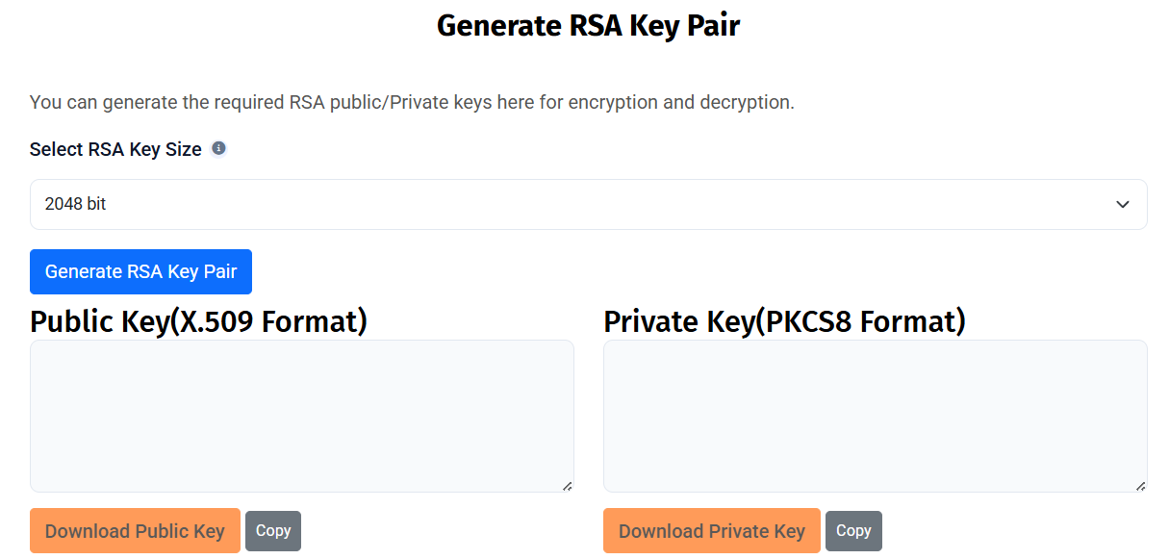

Step 3: Enter Plain Text
- In the input box, type your message
Example: Hello World
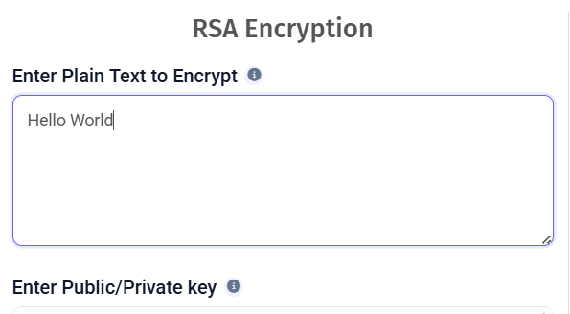

Step 4: Encrypt the Message
- Paste the Public Key
- Click on Encrypt
- Copy the generated encrypted text (cipher text)

Step 5: Decrypt the Message
- Paste the encrypted text into the decryption box
- Paste the Private Key
- Click on Decrypt

Step 6: Verify Output
- The original message will be displayed after decryption

Output Example
- Plain Text: Hello World
- Encrypted Text: a8F3kL9x... (random encrypted data)
- Decrypted Text: Hello World

Result
The message was successfully encrypted using the public key and decrypted using the private key with RSA algorithm.

Conclusion
RSA provides high security by using two different keys. It is widely used in secure data transmission, digital signatures, and encryption systems.

